Study App User Guide

# INTRODUCTION

The Study App is an app designed to help students in high school and college with being more efficient with their studies. The app features a timer and a to-do list.

# DIRECTIONS

**The Main Menu**

1. When you open the app, you will be greeted with a welcoming message and some information about the app. Press ENTER to move on after reading.
2. You will then be shown the menu, which should look something like this:

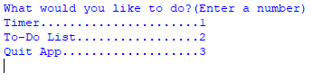

1. To use the timer, type the number 1 and then press ENTER. The Timer Menu will appear.  
   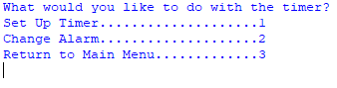
2. To use your to-do list, type the number 2 and press ENTER. The To-Do List Menu will appear.  
   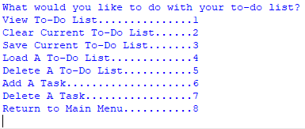
3. Whenever you want to close the app, type in the number 3 and press ENTER. You will be asked to confirm that you want to quit

**To Use The Timer**

1. At the menu, type the number 1 and press ENTER. The timer menu should then appear.



1. To use the timer, type the number 1 and then press ENTER. You will be asked a series of questions to set the timer up: 1)”How many minutes do you want to study?” 2) “Would you like a countdown timer?” 3) “Start the timer now?”  
     
   The timer will not start until you answer “y” to the last question.
2. When the timer runs out, a message will display and an alarm will play and continue to play until you close the timer.  
   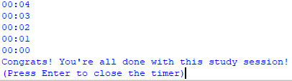
3. After pressing ENTER the Timer Menu will appear again.

**To Change the Timer Alarm**

You can change the alarm that will sound when your timer ends.

1. The file you want to use *must* be a MP3 file and moved to the folder named “Alarms”
2. Once the file is in the correct folder, open the program and navigate to the Timer Menu.
3. Once you are at the Timer Menu, type the number 2 and then press ENTER.
4. You will then be asked to name the file you want to use. Make sure you enter the same name, word-for-word, as the one in the folder. Then press ENTER.  
   
5. You will then see a message telling you that your alarm was successfully changed, unless you spelled the name wrong, the song isn’t in the folder, or isn’t an MP3 file. Then you will receive an error message.

**Your To-Do List Menu**

1. At the menu, type the number 2 and press ENTER. The To-Do List Menu will appear



**To View Your To-Do List**

1. Type the number 1 and press ENTER. Your list should appear. NOTE: When you open the app, your to-do list should be empty, until you add tasks or load a saved list.
2. When you are done viewing your to-do list, answer “y” to the question “Return to To-Do List Menu?”.  
   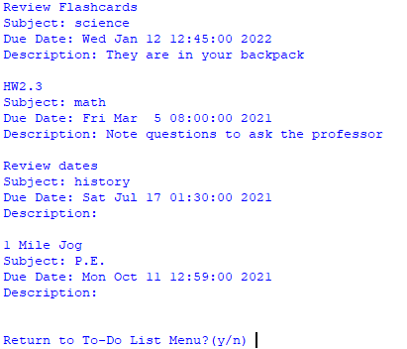

**To Add a Task to Your To-Do List**

1. Type the number 6 and press ENTER.
2. Follow the prompts and enter the name of the task, what subject it falls under, it’s due date (in military time), and any other details you would like to add (this is optional).
3. After answering each of these prompts, you will see a message confirming that your new task in saved in your to-do list.  
   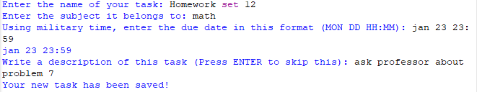
4. Press ENTER to return to the To-Do List Menu.

**To Delete a Task To-Do List**

1. Type the number 7 and press ENTER.
2. You will be asked to enter the name of the task you would like to delete. If you spell the task name wrong, or the task doesn’t exist, you will receive an error message.  
   
3. If the task you named is found, you will receive a message confirming that it was deleted from the list.  
   
4. Press ENTER to return to the To-Do List Menu.

**To Save Your To-Do List**

1. Type the number 3 and press ENTER.
2. You will be asked “What do you want to save the list as?” type in the name of this list and press ENTER.
3. You will then be shown a message confirming that your list was successfully saved. You should now be able to see a new text file with the name you entered in the ToDoLists folder.  
   Press ENTER to return to the To-Do List Menu.  
   
4. If there is already a list with the name you entered, you will receive a message saying so and your list will not be saved. Press ENTER after this message to return to the To-Do List Menu.  
   

**To Load a Saved To-Do List**

1. Type the number 4 and press ENTER.
2. Loading a saved to-do list will erase the current list. You will be asked if you want to confirm that you want to continue
3. Next, you will be asked to enter the *exact* name of the saved list. You can see all the lists in the folder named ToDoLists. If you spell the list incorrectly, or the list doesn’t exist, the app will take you back to the To-Do List Menu. Otherwise, you will see a message confirming that your to-do list was loaded successfully.  
   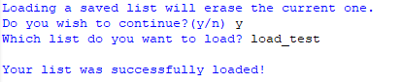
4. Press ENTER to return to the To-Do List Main Menu.
5. Now if you view your to-do list, you should see your loaded list.

**To Clear Your Current To-Do List**

1. Type the number 2 and press ENTER.
2. You will be asked to confirm that you want to clear the entire list.
3. After confirming, you will be shown a message confirming that your to-do list is now empty.  
   
4. Press ENTER to return to the To-Do List Menu.